 | UK Chinese Music Ensemble and  London Youlan Qin Society 伦敦幽兰琴社  Chinese Music Courses  29 September to 20 December 2021  Registration form | 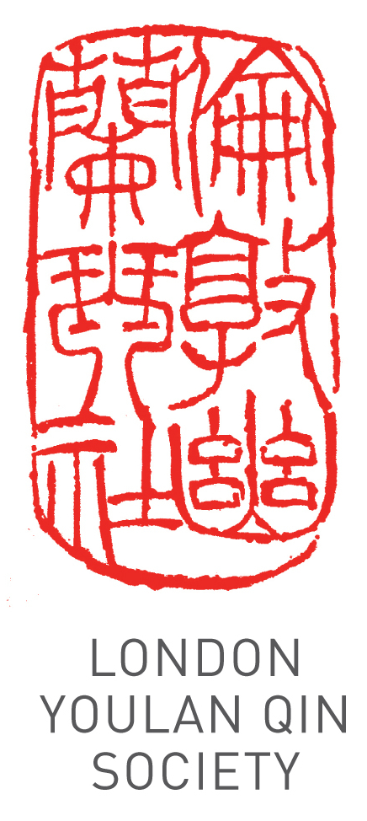
Applicant Details
Title (Dr/Mr/Ms/other):
Name:
Address:
Phone: Email:
Registration Information
Which instrument(s) do you wish to learn? |  | ..................
Do you already play the instrument? |  | Yes |  | No
If so, to what level? | Beginner | Intermediate |  | Advanced
Attendees are strongly encouraged to use their own instrument. A limited number are available for hire, on a first come first served basis. Please tick the box if you need to hire an instrument

Payment
12 weekly group lessons £300 intermediate/advanced, £240 all beginner group classes: £ …….
12 weekly individual 1-to-1 lessons £480 @£40/hour, 1-to-2 lessons £360 @£30/hour.
Time slot: …………………………… 10% discount for LYQS/UKCE members: …………
Total £ …….
Bank: HSBC
Account name: China Arts Ltd
Account number: 11440691
Sort Code: 40-20-07
IBAN: GB89HBUK40200711440691
BIC: HBUKGB4129V
Please pay by bank transfer, specifying your name as reference, and email a scan of the transaction. Please make your payment before 25 September 2021.

I wish to register for the 12 weeks of the course.

Signature: ____________________________ Date: ______________________
Please email the completed form and proof of payment (e.g. screen capture of the transaction) to info@ukchinesemusic.com.
Please note that the course fee cannot be refunded if the attendee misses any classes.

