 | London Youlan Qin Society 伦敦幽兰琴社  Chinese Music Summer School 2020  22 July-30 August  Registration Form | 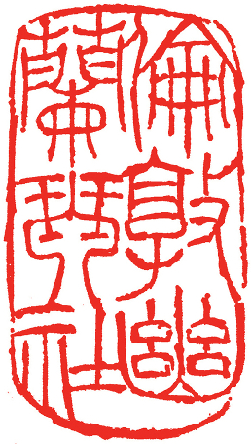
Applicant Details
Title (Dr/Mr/Ms/other):
Name:
Address:

Phone: Email:

Registration Information
Do you already play the guqin? |  | Yes | No
If so, to what level? | Beginner | Intermediate | Advanced
Attendees are strongly encouraged to use their own instrument. A very small number of instruments are available for hire, but only for people based in London who can collect in person.
Please tick the box if you need to hire an instrument

If you would like to join the LYQS mailing list, please tick the box
If you would like to become a member of the LYQS, please tick the box
LYQS members can join the WeChat group; please tick the box to join

Payment
6 weeks tuition beginners (£120) £ ……. Concessions/LYQS members (£110) £ …….
6 weeks tuition intermediate/advanced (£150) £ ……. Concessions/LYQS members (£135) £ …….
2 masterclasses: (£70) £ …….
Total £ ……. Please pay before 20 July.
I would like to pay by bank transfer (preferred). Please email a screen capture of the transaction to the secretary. The Society’s bank details are:
Santander Bank
For the credit of: THE LONDON YOULAN QIN SOCIETY (LYQS)
Sort Code: 09-01-27
Account number: 83251656
IBAN: GB05 ABBY 0901 2783 2516 56
BIC: ABBYGB2LXXX
Reference: [Your surname] [Your initial(s)] SS2020
I would like to pay by PayPal. The payment should be sent to londonyoulanqinshe@gmail.com. Please specify your full name and what the payment is for as reference; and select 'Paying for an item or service'.
If you pay by PayPal then our course fees are slightly higher, to include PayPal’s charges:
Beginners: £124.40 (concessions £114.05), Intermediate/Advanced: 155.40 (concessions 139.90)
Masterclasses: £72.70
After making payment, please forward the confirmation (or a screenshot of it) to the Secretary.

Declaration
I declare that the information that I have given is accurate at the time of submission and that I confirm my intention to attend the summer school and be registered as a participant.

Yes

I hereby give consent to the London Youlan Qin Society to use my personal information to contact me with regard to the summer school only, unless I have indicated for them to do so otherwise.

Yes No

Please indicate whether you consent to have your photo/video/media taken during the summer school. These may be used by the LYQS on our website and social media, and in future promotions for our summer schools and other events.

Yes No

If you do not consent, we will do our best to accommodate your request and avoid filming or photographing you. You must also indicate this during your time at the event so that we can identify you and take appropriate measures to avoid inadvertently capturing you on camera.

I wish to register for the Chinese Music Summer School.

Signature: ____________________________ Date: ______________________

Please email the completed form to the secretary at: jmgjoseph@btinternet.com.

